Paper Title
Author name^{1*}, Author names²
¹Affiliation for author 1 (incl. Department, Institute/University, City, Post/Zip code, Country)
²Affiliation for author 2 (incl. Department, Institute/University, City, Post/Zip code, Country)
* Corresponding author’s contact details (e-mail address, telephone number)(Only one corresponding author can be specified)

Abstract: This should not exceed 350 words. Abstracts should not cite references, figures or tables, and the use of abbreviations should be minimized. The abstract should include trial registration details, if appropriate.
​​​​​​​Keywords: Three to ten keywords representing the main content of the article

MAIN TEXT
This should contain the body of the article, and may also be broken into subsections with short, informative headings. The main text should be arranged under appropriate subheadings typed in sentence cases.

The main text should include the following elements:
- Motivation
- Research questions
- Related literature and theories
- Methodology
- Expected results

Please pay attention to:
- Please do not number the sections.
- References must be cited in the text using consecutive numbers in square brackets. For example [1].
- Do not include footnotes or text boxes.
- Please use sentence case for titles, headings and subheadings, with no unnecessary initial capital letters.
- Avoid including long URLs in the main body of the text, put them in the reference section with the name of the website.
- Ensure that permission has been obtained to reproduce any previously published materials (e.g. text sections, reproduced figures/tables, etc.) and make sure the original publications are correctly referenced.

Preparing Figures
- Please place figures and tables in the text where needed. Do NOT place figures or tables at the end of the document.
- Figures should be numbered and mentioned in the text. An example is shown in Figure 1.
- Please use high-resolution PNG or PDF files as figures whenever possible.
- It is the responsibility of the author(s) to obtain permission from the copyright holder to reproduce figures (or tables) that have previously been published elsewhere. Permission should be indicated in the figure legend, and the original source included in the reference list.

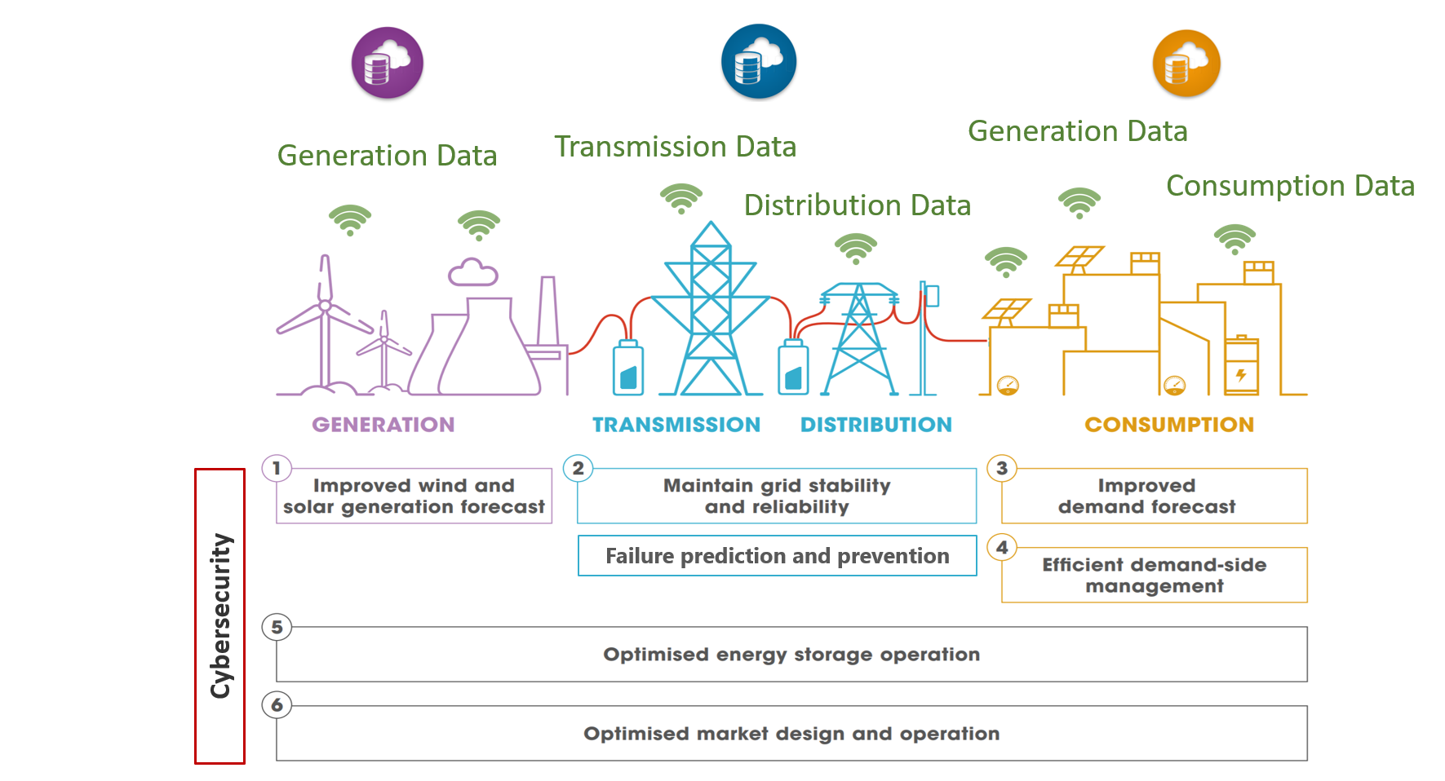
Figure 1. Digital transformation of the energy sector [1]

Preparing tables
Tables should be numbered and cited in the text in sequence using Arabic numerals with single line space (e.g., shown in Table 1). Tables should not be embedded as figures or spreadsheet files but should be formatted using the ‘Table object’ function in your word processing program.

Note (example of heading 3)
Larger datasets, or tables too wide for the A4 landscape page, can be in the appendix before the REFERENCES section.

Table 1. Themes of the full papers from Energy Informatics.Academy(EI.A) Asia 2021 conference [2]
Theme | Paper title
Energy systems | - A Scoping Review of Deep Neural Networks for Electric Load Forecasting  - Advanced Voltage Control Method for Improving the Voltage Quality of Low-Voltage Distribution Networks with Photovoltaic Penetrations  - Optimization of district heating production with thermal storage using mixed-integer nonlinear programming with a new initialization approach
Energy in buildings | - Climatization and Luminosity Optimization of Buildings Using Genetic Algorithm, Random Forest, and Regression Models  - A QR code based framework for auto-configuration of IoT sensor networks in buildings  - A Digital Twin Framework for Improving Energy Efficiency and Occupant Comfort in Public and Commercial Buildings
Energy communities | - Software toolchain to enhance the management and integration of a sustainable campus model  - Web-based platform for the management of citizen energy communities and their members  - An Overview of Digitalization for the Building-to-Grid Ecosystem
Electric Vehicles | - Joint Optimal Allocation of Electric Vehicle Charging Stations and Renewable Energy Sources Including CO2 Emissions  - A generic agent-based framework for modeling business ecosystems: a case study of electric vehicle home charging  - Electric Vehicles as Distribution Grid Batteries: A Reality Check  - Methodology for identifying technical details of Smart Energy Solutions and Research Gaps in Smart Grid: An Example of Electric Vehicles in the energy system
Energy in industry | - Greenhouse Industry 4.0 – Digital Twin Technology for Commercial Greenhouses  - A Multi-objective Optimization Platform for Artificial Lighting System in Commercial Greenhouses  - Agent Based Coordination Protocol for System of Cyber-Physical Systems
Energy markets | - Local Energy Markets - An IT-architecture Design  - Industrial consumers’ electricity market participation options: A case study of an industrial cooling process in Denmark  - Analysis and forecasting of crude oil price based on the variable selection-LSTM integrated model
Energy policy & regulation | - Evaluating the CO2 abatement effects of low-carbon city policy in China: A quasi-natural experiment  - Digitalisation Potentials in the Electricity Ecosystem: Lesson learnt from the Comparison between Germany and Denmark

List of abbreviations
- If abbreviations are used in the text they should be defined in the text at first use, and a list of abbreviations should be provided.
- The list of abbreviations should be placed here (before the Acknowledgements section).
- Please do not use tables in this section.
This section should be, for example:
EI.A: Energy Informatics.Academy
MAS: Multi-agent system

Acknowledgements
Please acknowledge anyone who contributed towards the article who does not meet the criteria for authorship including anyone who provided professional writing services or materials. Authors should obtain permission to acknowledge from all those mentioned in the Acknowledgements section.
If you do not have anyone to acknowledge, please write "Not applicable" in this section.

REFERENCES
Please use the Springer Vancouver reference style. You can download it from the Endnote link here. You can generate references with the springer Vancouver style here.

Please provide an access date for all internet references (e.g., webpage, online document/report, etc) as the examples below:
- Jørgensen BN (2021) Keynote speech: Key research fields in energy Informatics. In: 1st Energy Informatics.Academy Asia Ph.D. Workshop. https://www.youtube.com/watch?v=3ohCuvFY6DI. Accessed 26 Jun 2021
- Ma, Z., Jørgensen, B.H., Chen, G. et al. Welcome message from the organizers at the 1st Energy Informatics. Academy Conference Asia (EI.A Asia 2021). Energy Inform 4, 45 (2021). https://doi.org/10.1186/s42162-021-00147-7

